**Guidelines for Data Visualization and Analysis Project**

**About the Project:**

In this project, you will be working with a dataset from the Superstore, aiming to answer 30 scenario-based questions through data visualisation and analysis. Your objective is to select the best chart for each question, explain your choice. This project will showcase your proficiency in data visualisation, critical thinking, and effective communication.

**Skills Required:**

* Proficiency in data visualisation concepts and techniques.
* Familiarity with Tableau or a similar data visualisation tool.
* Strong analytical and problem-solving skills.
* Ability to choose appropriate charts based on data characteristics and question requirements.
* Clear and concise communication skills.

**Deliverables:**

* A Google document containing solutions to the scenario based questions including the screenshot of relevant chart picked for each scenario, presented in a concise and well-structured format. Make sure to provide explanations that highlight your problem-solving skills.

**Rubrics for Assessment:**

Question Responses:

* Accuracy and completeness of answers for all 30 questions.
* Clear and concise explanations that address the question's context.

Chart Selection and Explanation:

* Thoughtful rationale for choosing specific chart types.
* Justification based on data characteristics, context, and communication goals.

Creative Enhancements:

* Effective use of creative elements to enhance visualisation quality.
* Enhancements that contribute to better understanding or engagement.

**Note**:

* Duplicate this document and proceed to write your solutions.
* For each scenario and question, provide a justification for the choice of chart type. Explain why it is the best option to visualise the data effectively.
* Attach screenshots of the charts you have created in Tableau for each scenario and question using the Superstore dataset. Label them clearly to match the corresponding questions in the Google Document.
* Submit the duplicated google doc file after completion.

Use these guidelines to structure your data visualisation and analysis project. Remember to maintain consistency in your responses, explanations, and visualisation styles. This project will not only demonstrate your skills but also your ability to effectively communicate complex information through visualisations. Good luck!

**Problem Statement: Choose the Best chart for any 30 scenario based questions from Superstore Dataset.**

Imagine you are a data enthusiast aiming to excel in data visualisation and analysis. In this task, you have been given any 30 scenario-based questions derived from the Superstore dataset, and your objective is to provide insightful answers using appropriate charts. For each question, you need to select a chart that best represents the data, explain why you chose that specific chart, and then proceed to build the chosen chart using Tableau.

Your responses should be succinct, organised, and illustrative of your problem-solving capabilities.

**Dataset Link:**

<https://community.tableau.com/s/question/0D54T00000CWeX8SAL/sample-superstore-sales-excelxls>

**Please keep in mind:**

1. **Answer Completion**: Ensure that you furnish answers for all any 30 questions and build charts for them.
2. **Encouraged Creativity**: Don't hesitate to employ visuals, creative elements, or any other innovative approaches to enhance the quality of your responses.

By completing this task effectively, you'll not only demonstrate your proficiency in data visualisation and analysis but also showcase your ability to effectively communicate complex concepts through both text and charts.

**Good luck!**

**Questions:**

1. Which product categories have the highest total sales in the "Superstore" dataset?

**Rationale:** A bar chart effectively compares the total sales across different product categories, making it easy to identify which categories have the highest sales.

**Explanation:** Bar charts provide a clear visual comparison of different categories, with the length of each bar representing the total sales for each category.

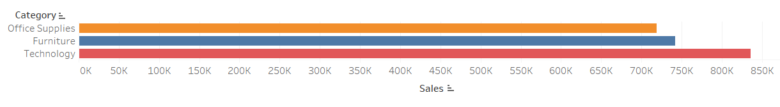

1. How do the monthly sales amounts change over the course of a year?

**Rationale:** Line charts are ideal for showing trends over time, such as changes in sales amounts over months.

**Explanation:** Line charts help in visualizing the fluctuation and trends in sales over each month, making it easier to observe patterns and seasonal effects.

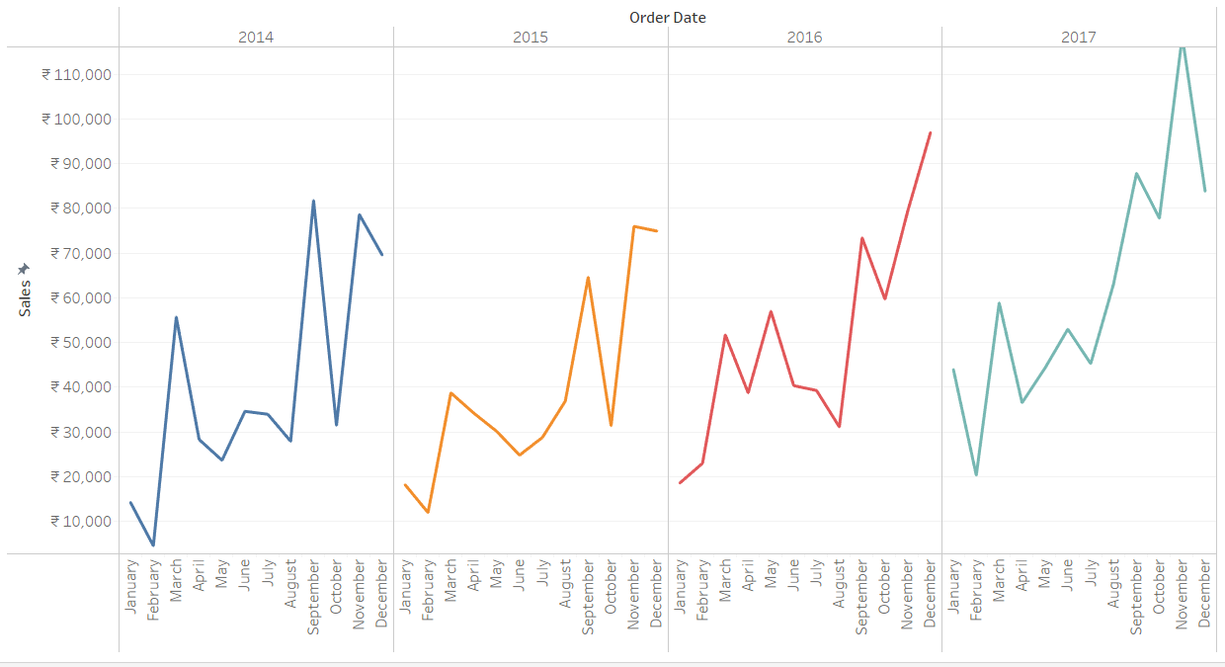

1. How is the total sales amount distributed among different product categories?

**Rationale:** Pie charts are useful for showing the proportion of total sales each product category contributes.

**Explanation:** By displaying each category as a slice of the pie, the chart helps in understanding the relative sales distribution among categories.

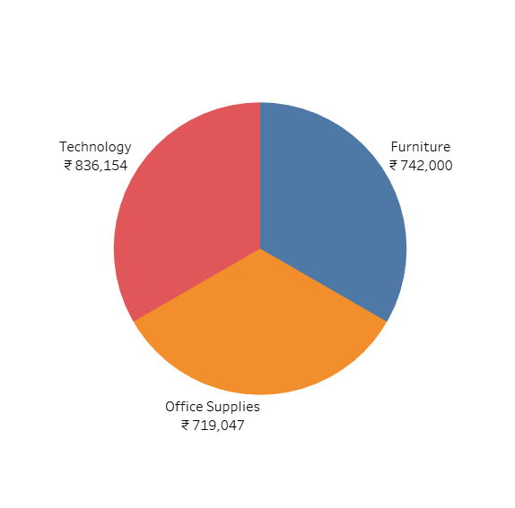

1. Can we analyze the sales performance of individual customers over time?

**Rationale:** Scatter charts can show sales performance over time, while scatter plots can show individual data points for sales per customer over time.

**Explanation:** Scatter charts can help track sales trends for individual customers, with scatter charts highlighting overall trends and scatter plots showing detailed individual sales events.

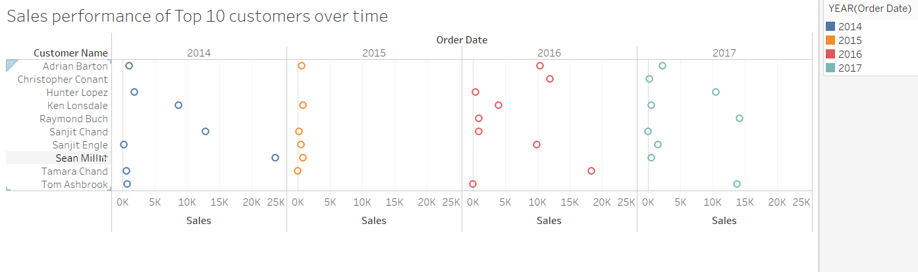

1. How do sales vary based on different days of the week and product categories?

**Rationale:** this maps are effective for displaying data distributions across two categorical variables.

**Explanation: this**  can show the intensity of sales for each day of the week across different product categories, with color gradients indicating sales volume.

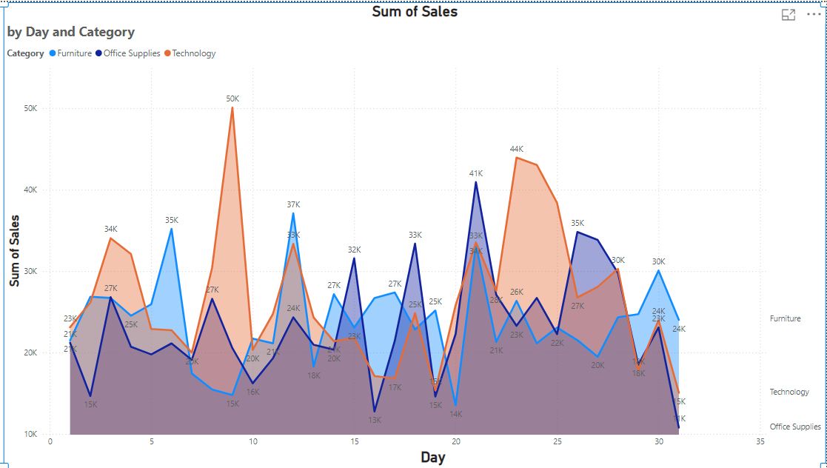

1. Can we visualise the sales growth of different product categories over time?

**Rationale:** Bar charts can effectively display the growth trends of sales for different categories over time.

**Explanation:** Different bar for each product category can show how sales have grown or declined over the selected time period

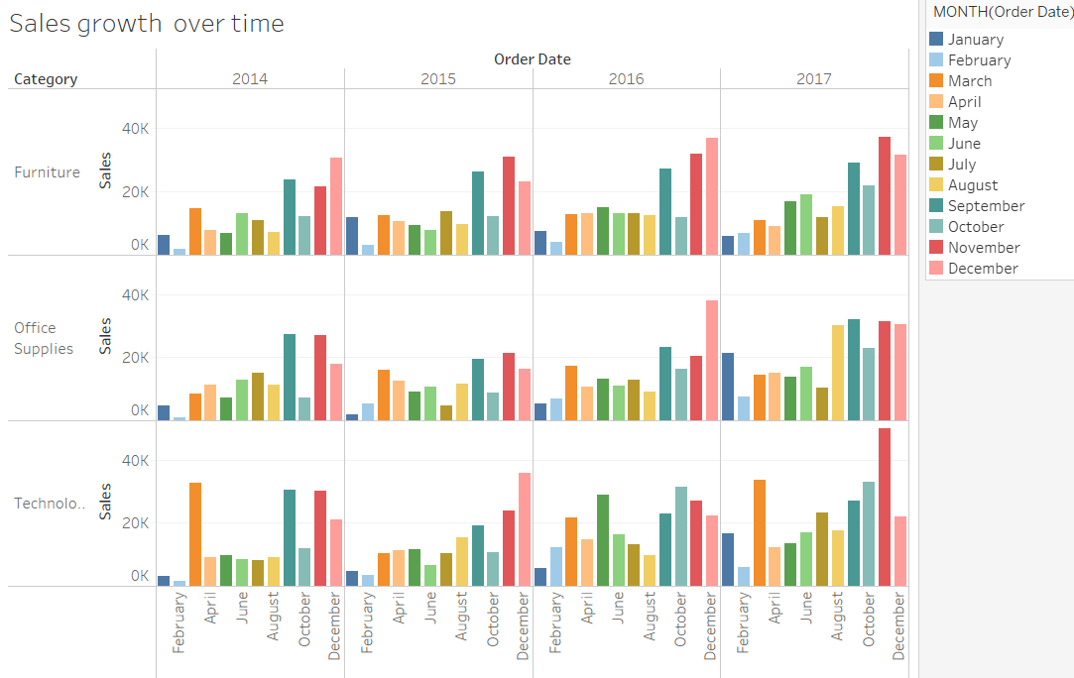

1. How does the sales distribution vary across different regions in the "Superstore" dataset?

**Rationale:** Box plots are useful for showing the distribution of sales data across different regions.

**Explanation:** Box plots can highlight the spread and central tendency of sales in different regions, including outliers.

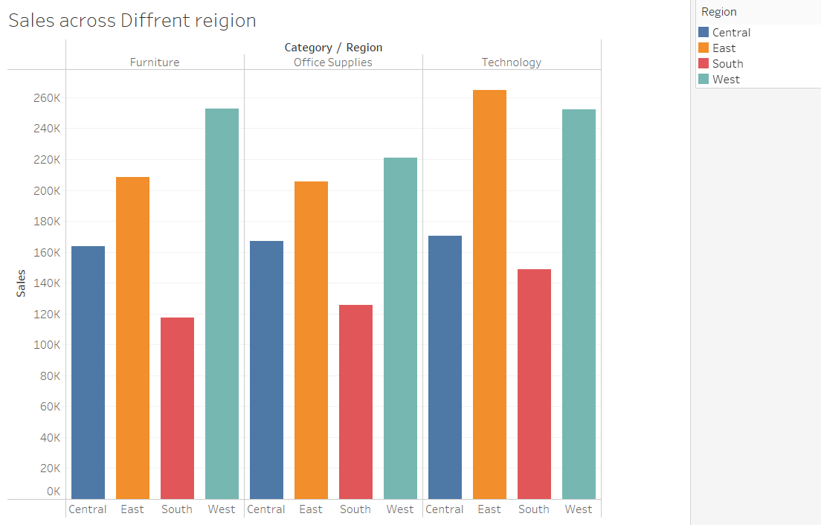

1. Can we visualise the composition of profits across various subcategories within different customer segments?

**Rationale:** Stacked bar charts can show the composition of profits within subcategories and customer segments.

**Explanation:** The chart can display how profits are distributed across subcategories within each customer segment, with different colors representing different subcategories.

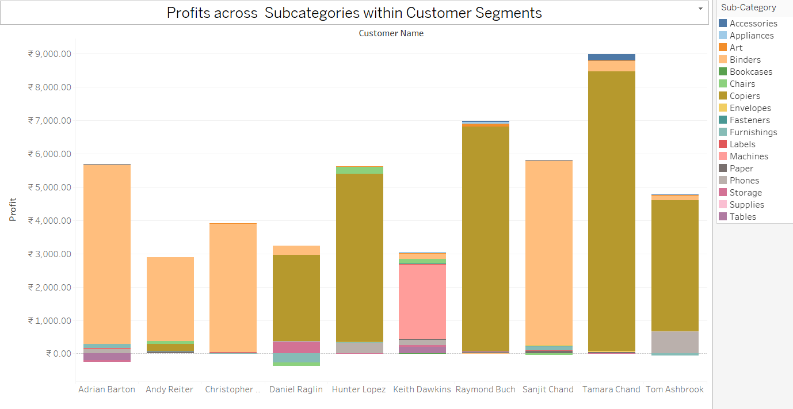

1. What is the percentage contribution of each region to the overall sales?

**Rationale:** Pie charts effectively show percentage contributions of different parts to a whole.

**Explanation:** Each region’s contribution to total sales is represented as a slice of the pie, providing a clear visual of regional sales distribution.

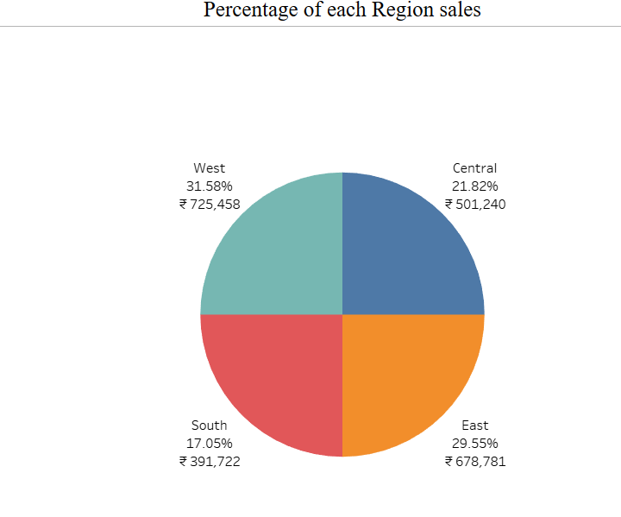

1. Can we visualise the profit margins associated with different shipping modes and customer segments?

**Rationale:** Bar charts can compare profit margins across different shipping modes and customer segments.

**Explanation:** Separate bars for each shipping mode within each customer segment can show the variation in profit margins clearly.

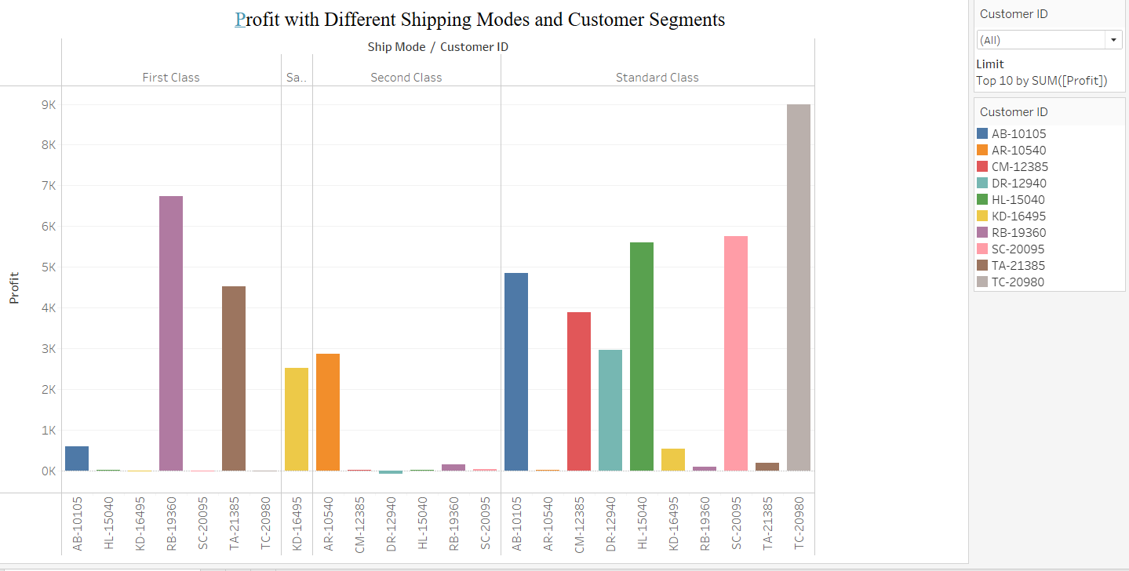

1. How long does it take to process orders for different product categories?

**Rationale:** Box plots show the distribution and spread of order processing times across different categories.

**Explanation:** This chart can highlight the median processing time and the range (including outliers) for each product category.

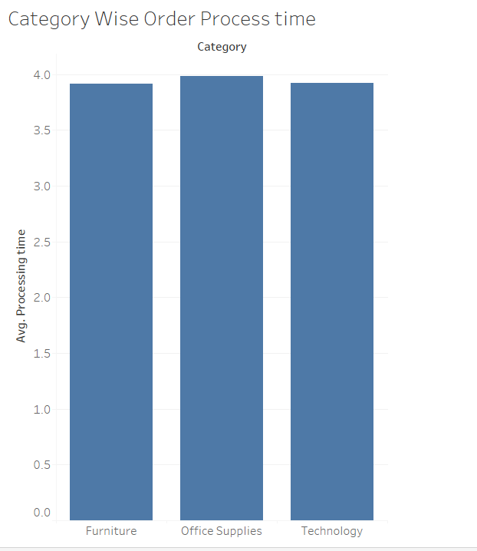

1. How do discounts affect overall profit?

**Rationale:** Scatter plots can show the relationship between two continuous variables, such as discount rates and profits.

**Explanation:** Each point represents a discount-profit pair, helping to visualize any correlation between discounts and overall profit.

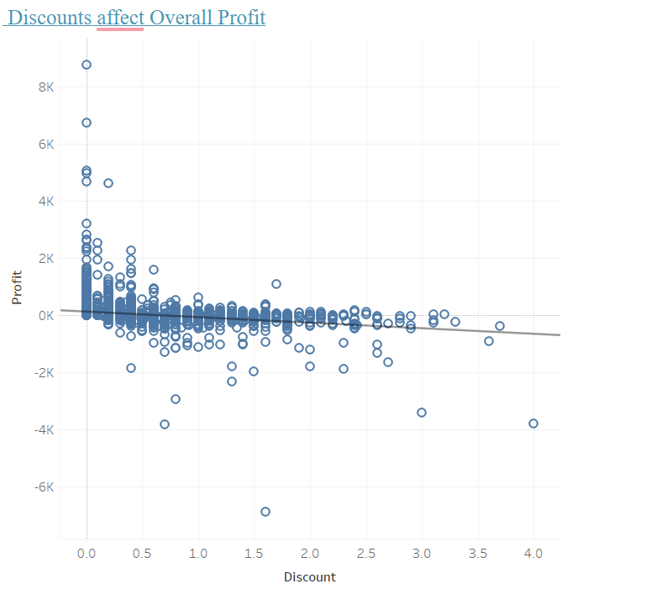

2nd chart

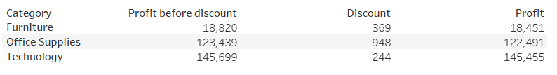

1. Can we visualise the relationship between product sales and profitability for different product categories?

**Rationale:** Scatter plots can illustrate the relationship between two continuous variables.

**Explanation:** This chart can show each product category’s sales and corresponding profitability, highlighting any correlation or trend.

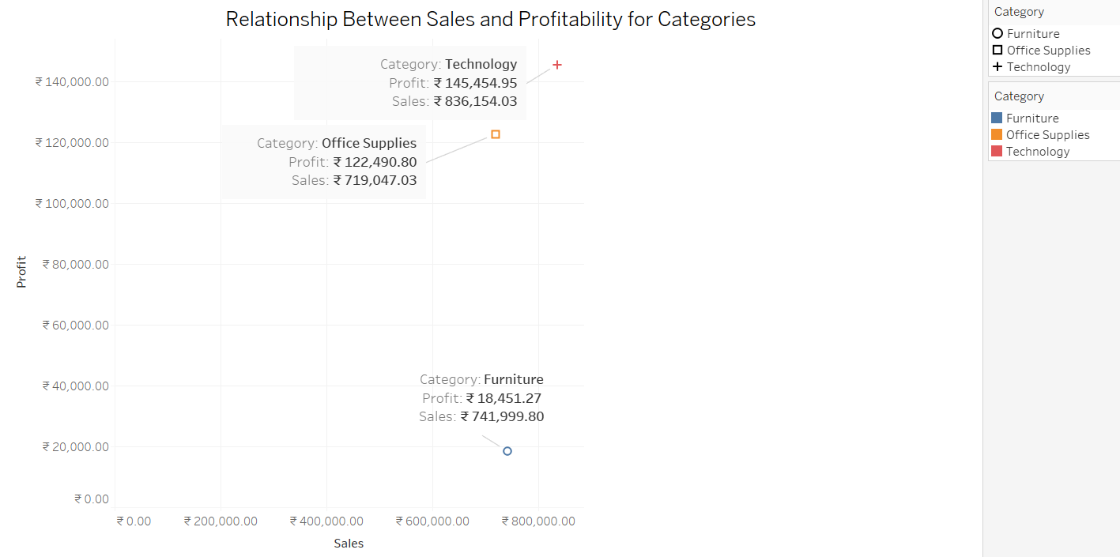

1. What is the distribution of order quantities for products in the dataset?

**Rationale:** Histograms show the distribution of a single continuous variable, such as order quantities.

**Explanation:** The histogram will display the frequency of different order quantities, helping to understand common order sizes.

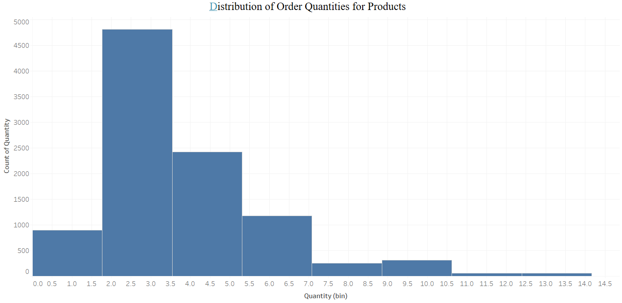

1. How do the profit distributions vary across different product categories?

**Rationale:** scatter plots can compare the distribution of profits across multiple categories.

**Explanation:** They will show product category’s profits, providing insights into profitability variability.

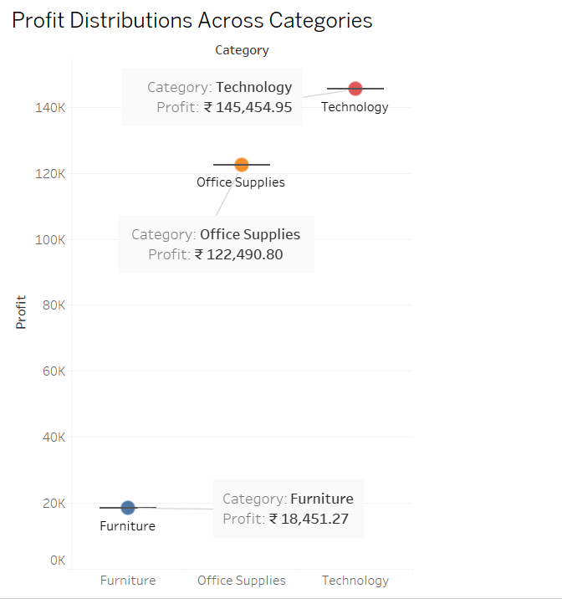

1. Can we compare the shipping time distributions for different shipping modes?

**Rationale:** Box plots are ideal for comparing distributions across different groups.

**Explanation:** This chart will show the distribution of shipping times for each shipping mode, highlighting median times and variability.

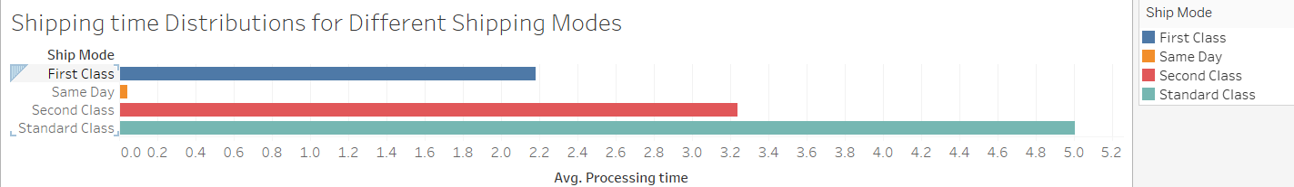

1. What is the monthly trend in the number of orders shipped?

**Rationale:** Line charts are effective for showing trends over time.

**Explanation:** This chart will display the number of orders shipped each month, highlighting trends and patterns.

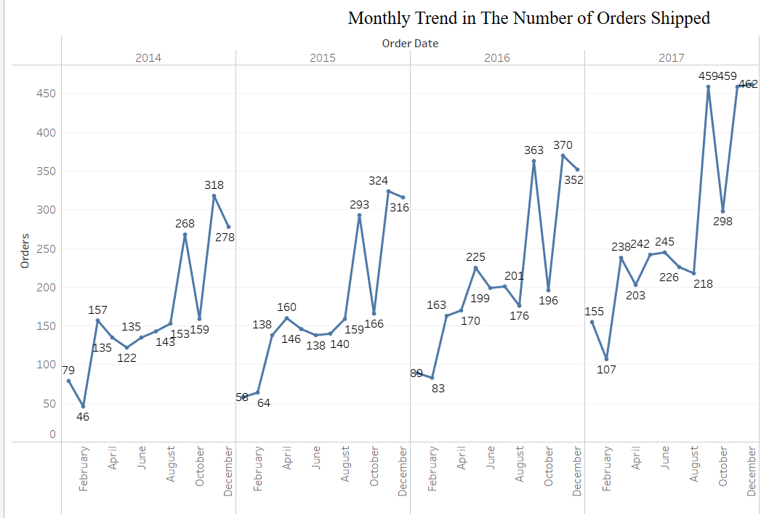

1. How do different customer segments perform in terms of sales and discount rates?

**Rationale:** Scatter plots can show the relationship between sales and discount rates across segments.

**Explanation:** Each point represents a customer segment, with the position and size indicating sales and discount rates.

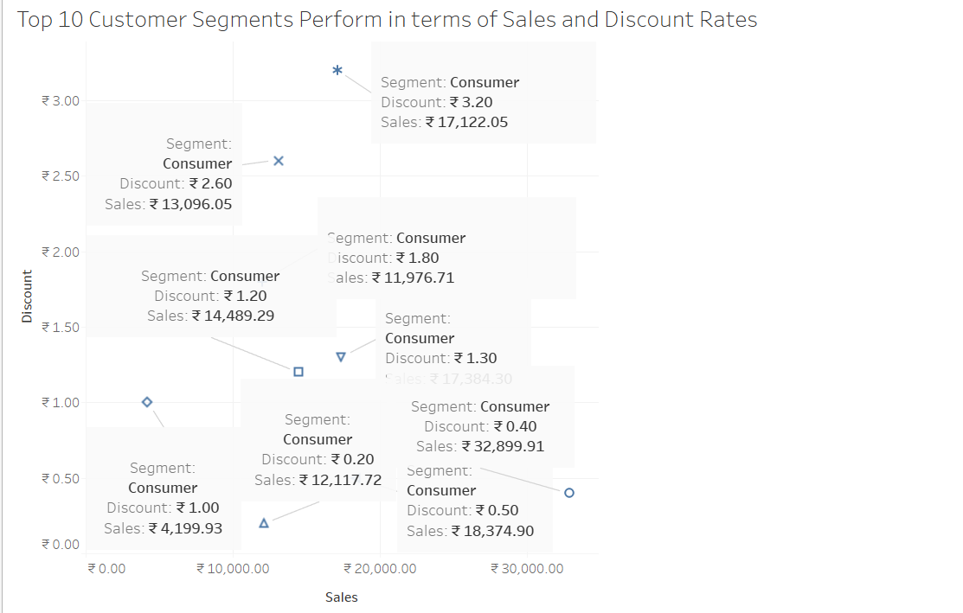

1. What are the sales and profit trends across different product subcategories and regions in the Superstore dataset?

**Rationale:** Line charts with multiple lines or dual-axis charts can display trends for different subcategories and regions simultaneously.

**Explanation:** This chart will show how sales and profits have changed over time for each subcategory and region.

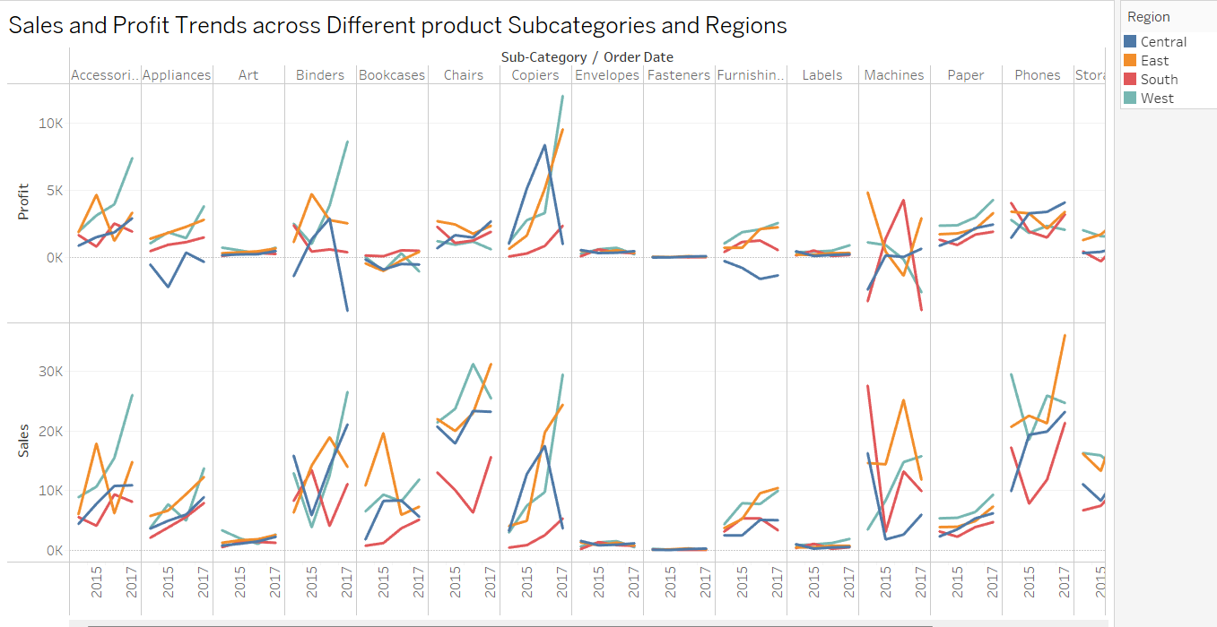

1. What is the average delivery duration for different regions and ship modes?

**Rationale:** Grouped bar charts can compare averages across multiple categories.

**Explanation:** This chart will show the average delivery duration for each region and shipping mode, facilitating easy comparison.

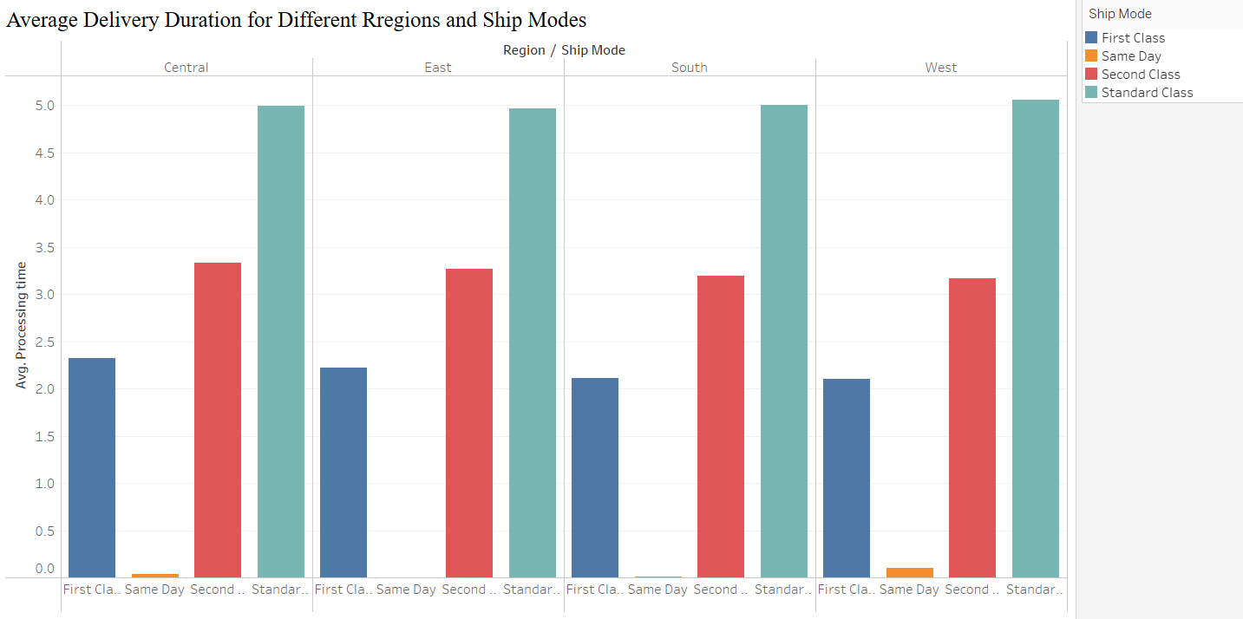

1. How has the average order quantity changed over the years for various product categories?

**Rationale:** Line charts are ideal for showing changes over time.

**Explanation:** This chart will display the trend in average order quantities for different product categories over the years.

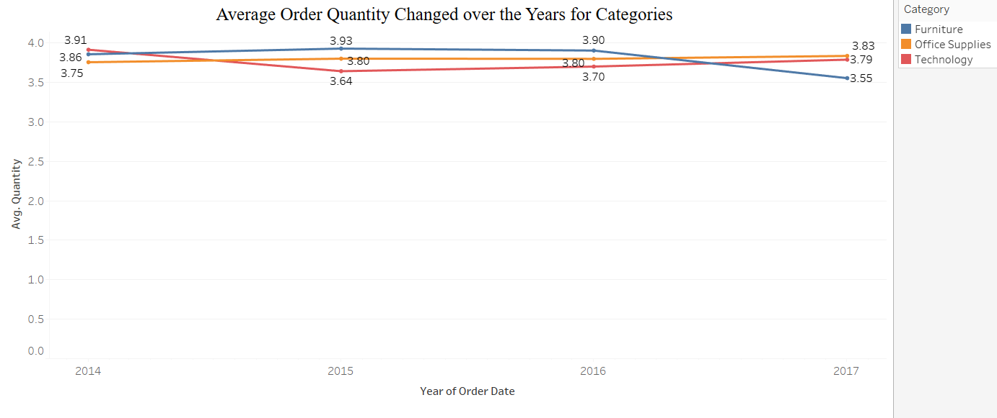

1. Can we visualise the correlation between discount rates and order quantities for different customer segments?

**Rationale:** Scatter plots show correlations between two variables.

**Explanation:** Each point represents a discount-order quantity pair, helping to visualize correlations for different customer segments.

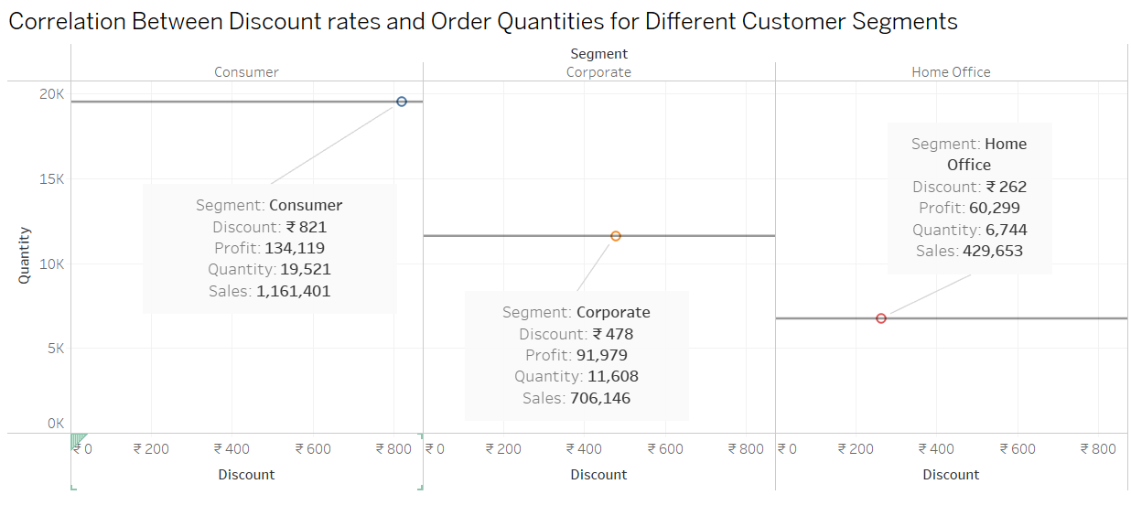

1. What is the proportion of orders returned in each region within the Superstore dataset?

**Rationale:** Pie charts show proportions effectively.

**Explanation:** This chart will show the proportion (or number) of orders returned in each region.

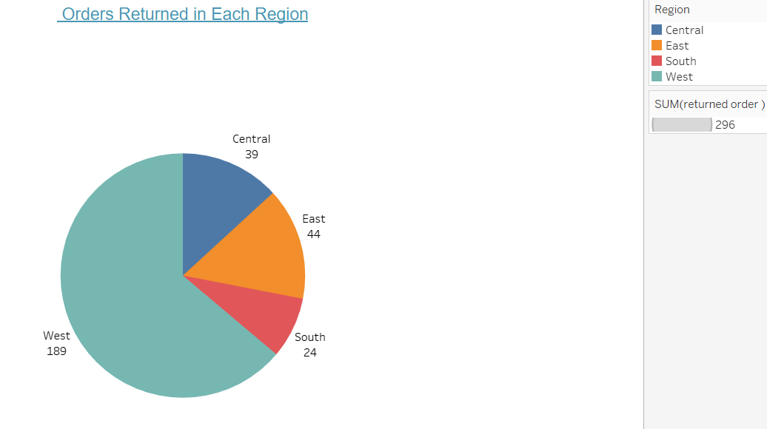

1. Can you compare the profit of different products for different subcategories?

**Rationale:** Bar charts can compare profits across multiple dimensions.

**Explanation:** This chart will show the profits for different products within each subcategory, making comparisons straightforward.

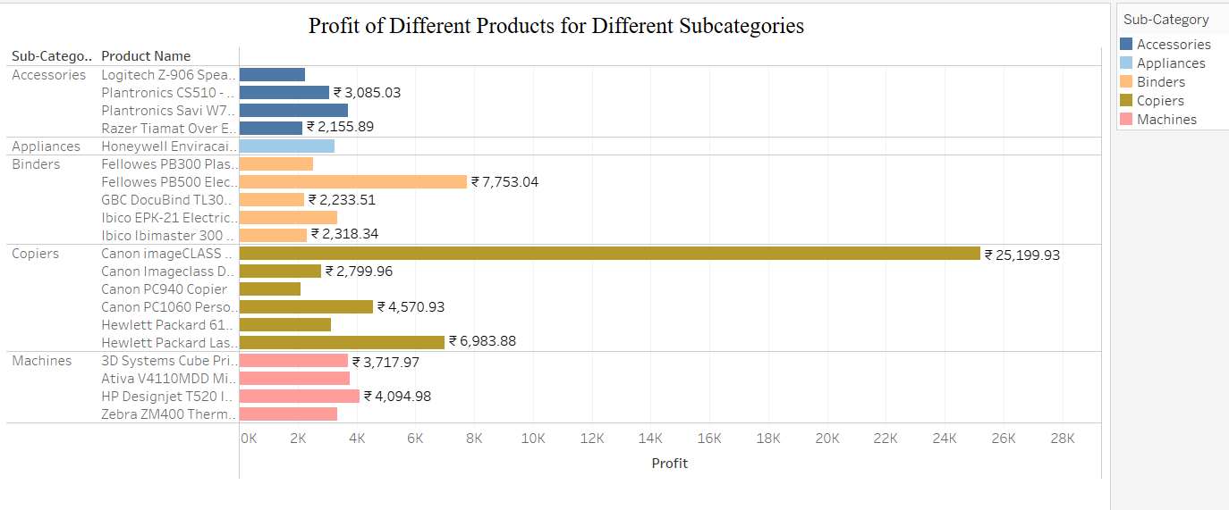

1. Which shipping mode is the most commonly used in the Sample Superstore dataset?

**Rationale:** Bar charts are effective for comparing frequencies.

**Explanation:** This chart will show the count of orders for each shipping mode, highlighting the most commonly used mode.

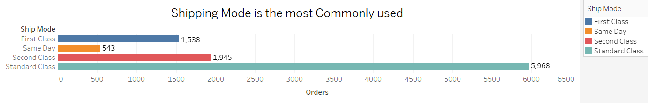

1. How does the sales performance of different regions evolve throughout the quarters of a year?

**Rationale:** Line charts can show trends and comparisons over time.

**Explanation:** This chart will display the sales performance of each region for each quarter, facilitating trend analysis.

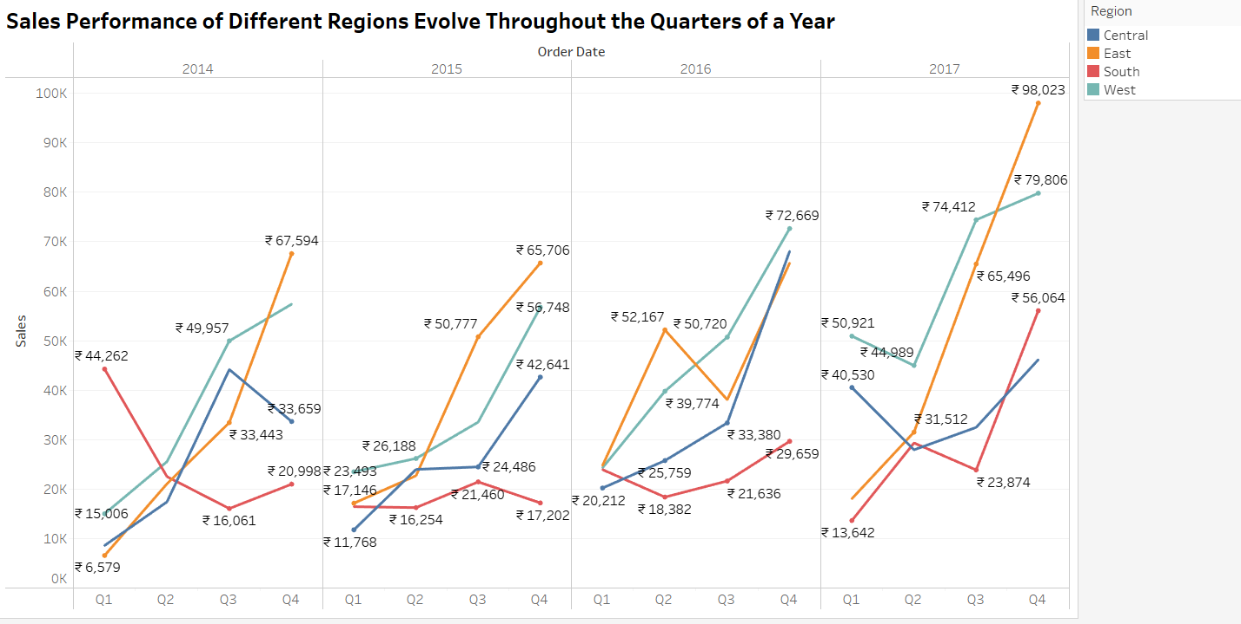

1. What is the distribution of order priorities across different product categories?

**Rationale:** bar charts can show the composition of different categories within a whole.

**Explanation:** This chart will display the distribution of order priorities within each product category.

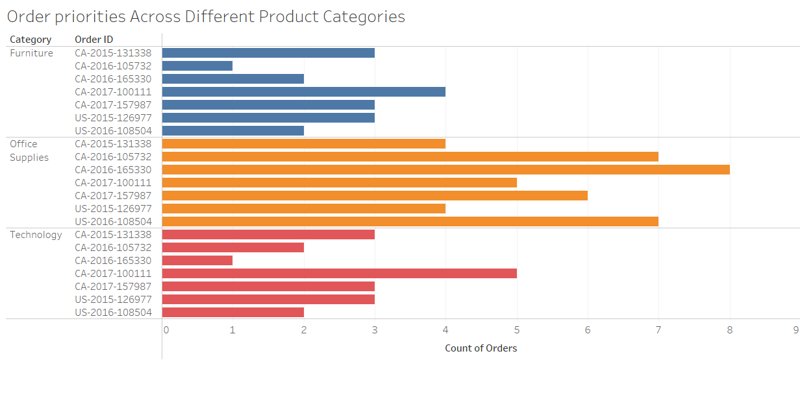

1. What is the relationship between discounts and sales?

**Rationale:** Scatter plots show the relationship between two continuous variables.

**Explanation:** Each point represents a discount-sales pair, helping to visualize any correlation between discounts and sales.

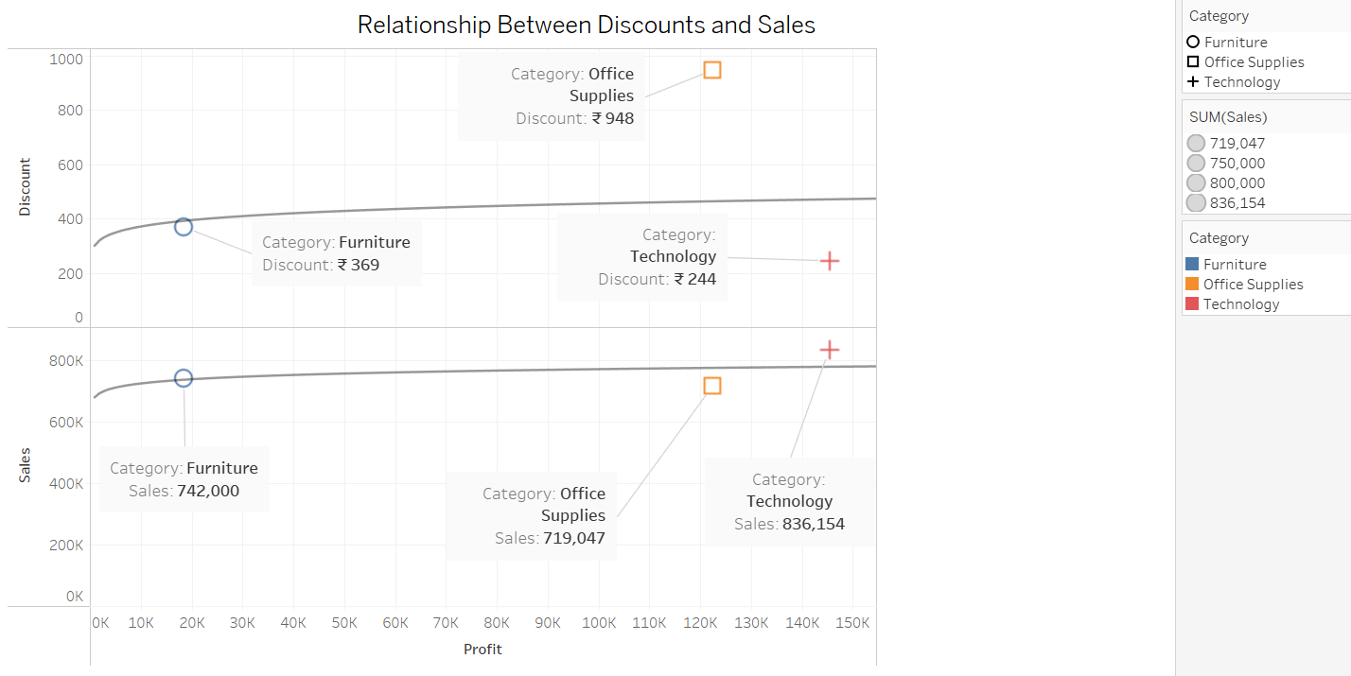

1. How does the average order value differ between repeat customers and new customers?

**Rationale:** bar charts can compare averages across different groups.

**Explanation:** This chart will show the average order value for repeat customers customers, facilitating comparison.

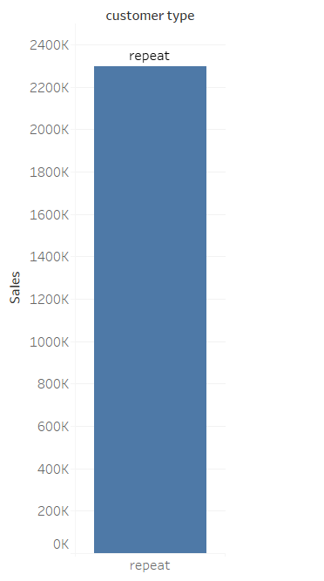

1. What is the geographical distribution of returns and its impact on overall profitability?

Map Chart (for geographical

